CSC 265 Lab Assignment 1

Due on 9/21/2017 11:59 pm

1. Use “traceroute” to get delay measurement from two different sites, (e.g. [www.google.com](http://www.google.com), [www.southernct.edu)](http://www.southernct.edu)). Screenshot each traceroute result and explain your findings. (address of the website, number of routers, if packets are missing, delays and etc.)

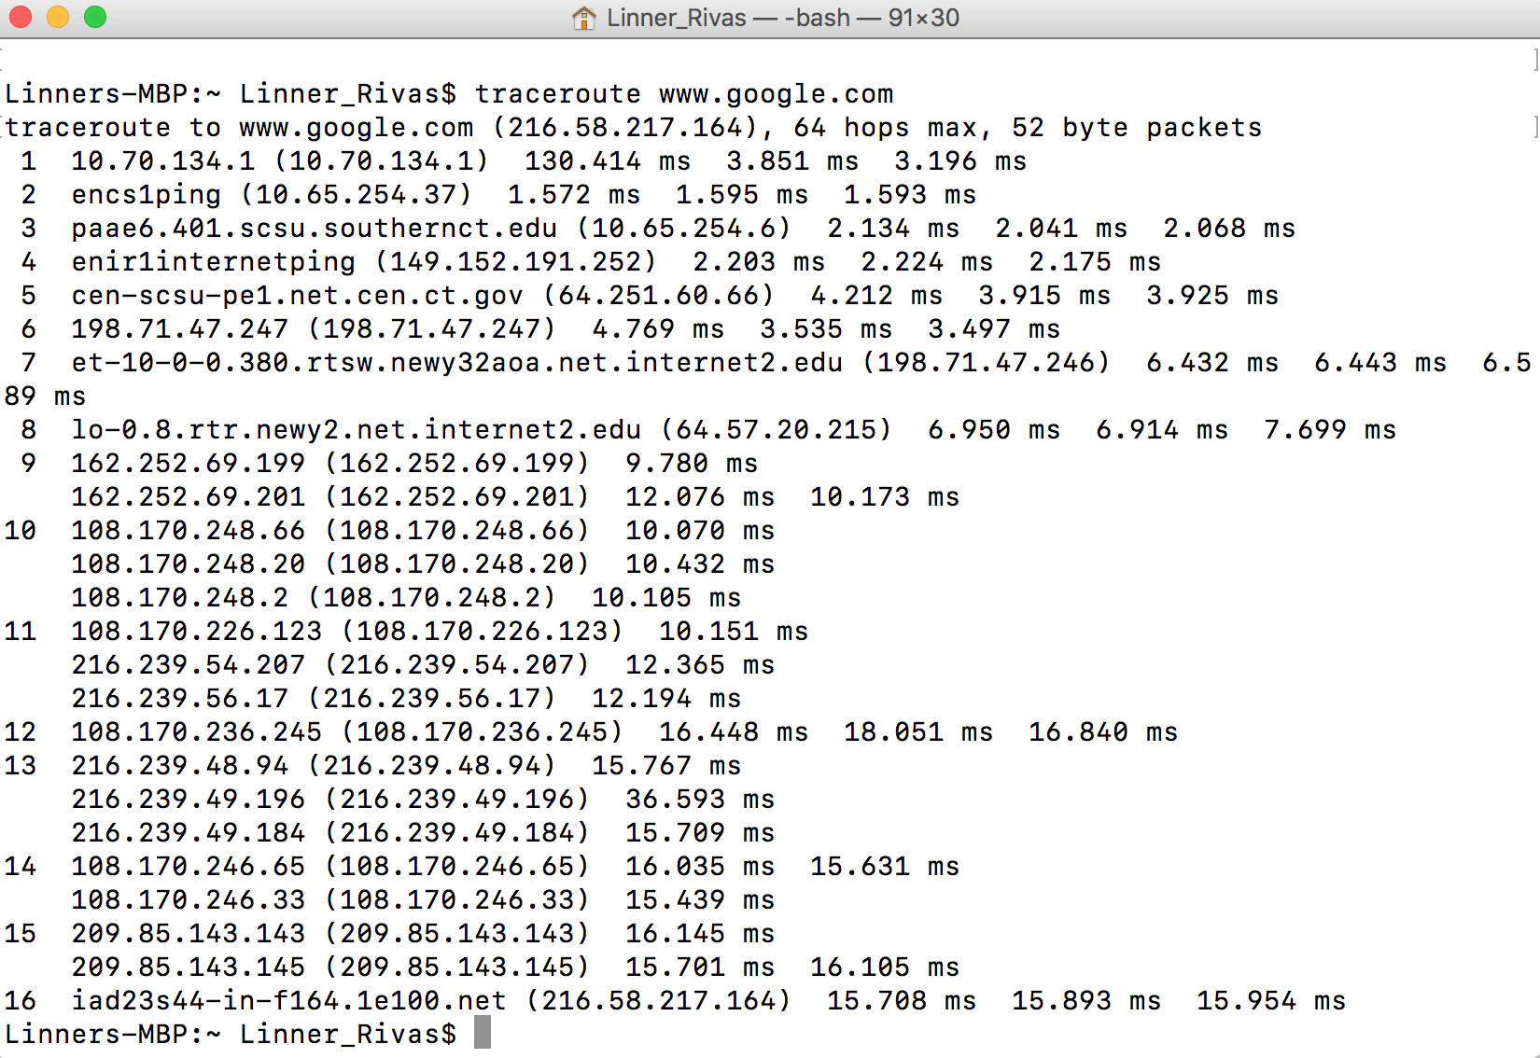

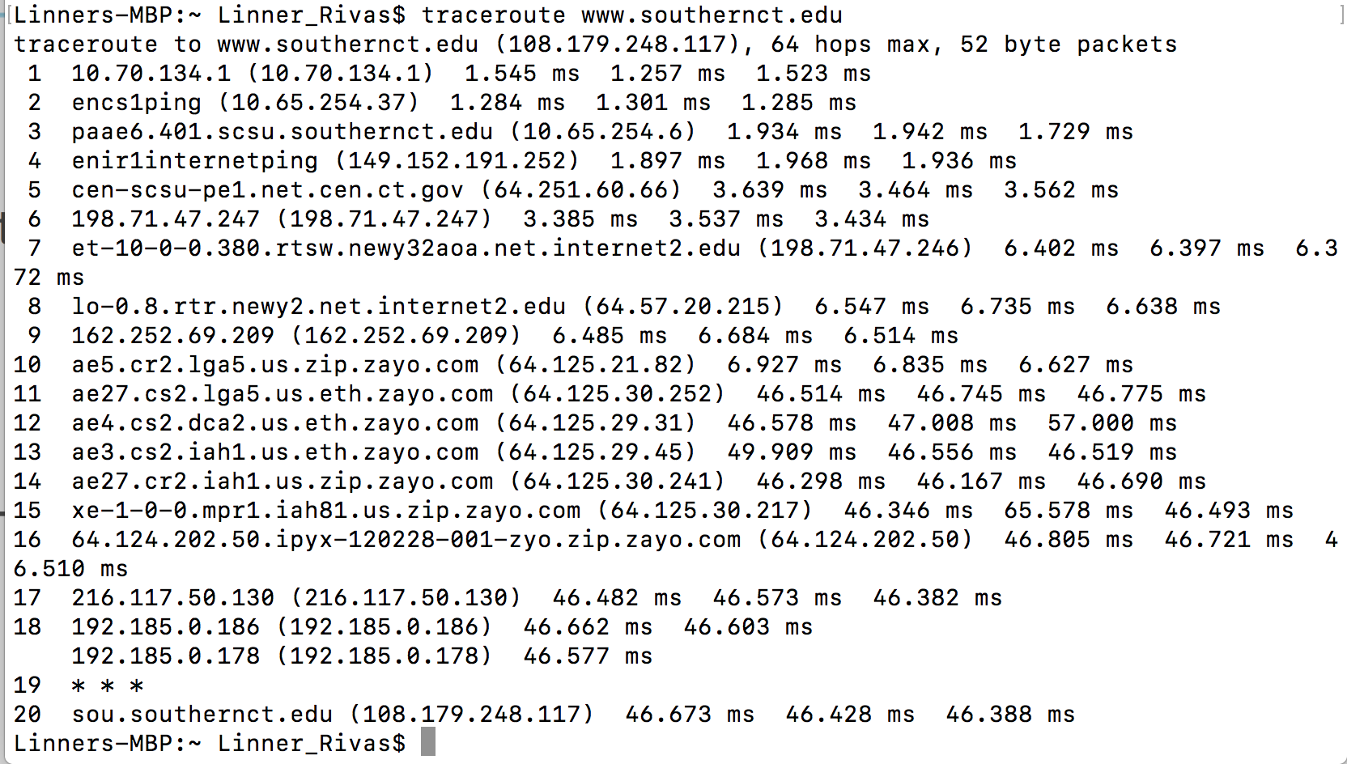

1. Use wireshark to monitor your own computer’s network activity. List up to 10 different protocols that appear in the protocol column in the unfiltered packet-listing window. (Screenshot is required)
2. TLSv1.2
3. TCP
4. NTP
5. DB-LSP-DISC
6. QUIC
7. DNS
8. MDNS
9. NAT-PMP
10. HTTP/XML
11. NBNS
12. ARP

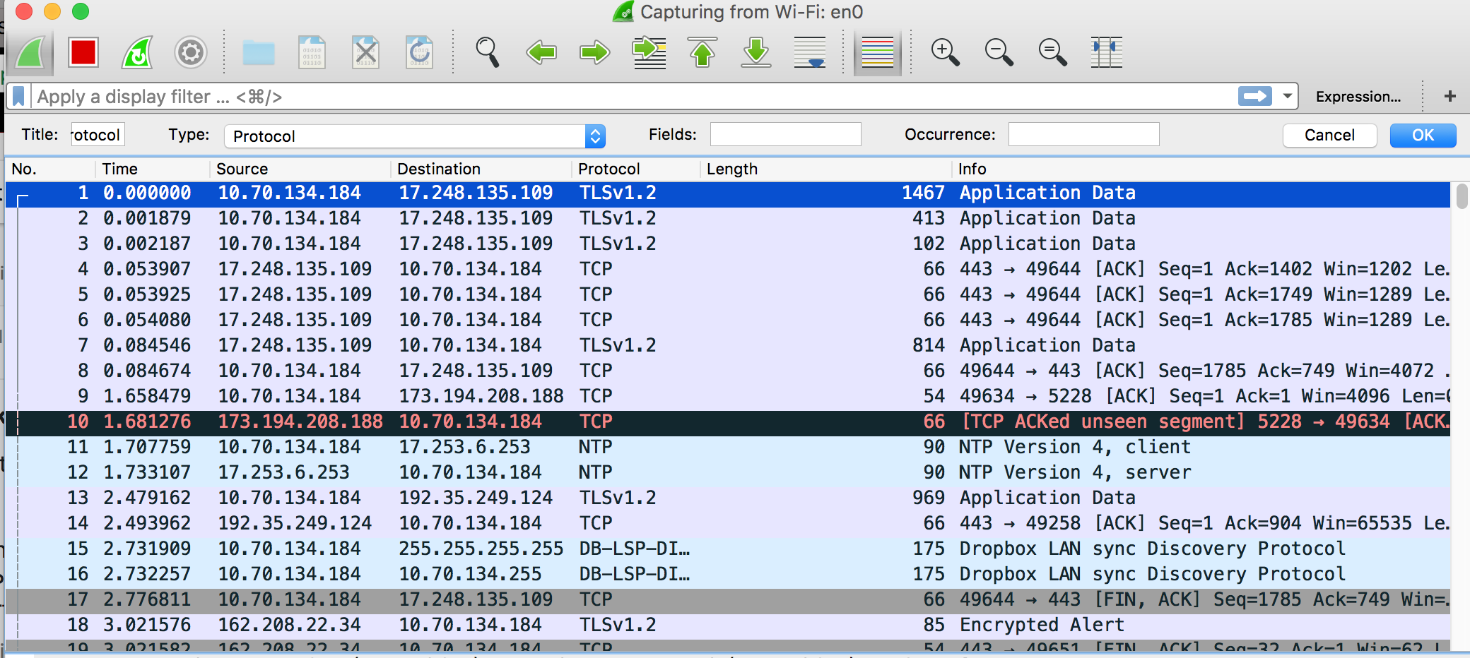

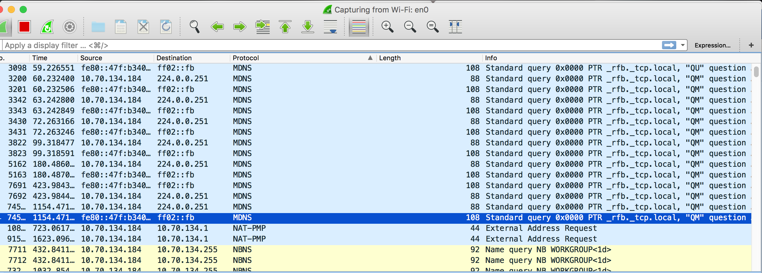

1. Use “ping” to reach two different websites and use wireshark to capture your ping packets. Use wireshark to capture your “traceroute” packets from question 1. (Screenshots are required) What are the protocols they use?

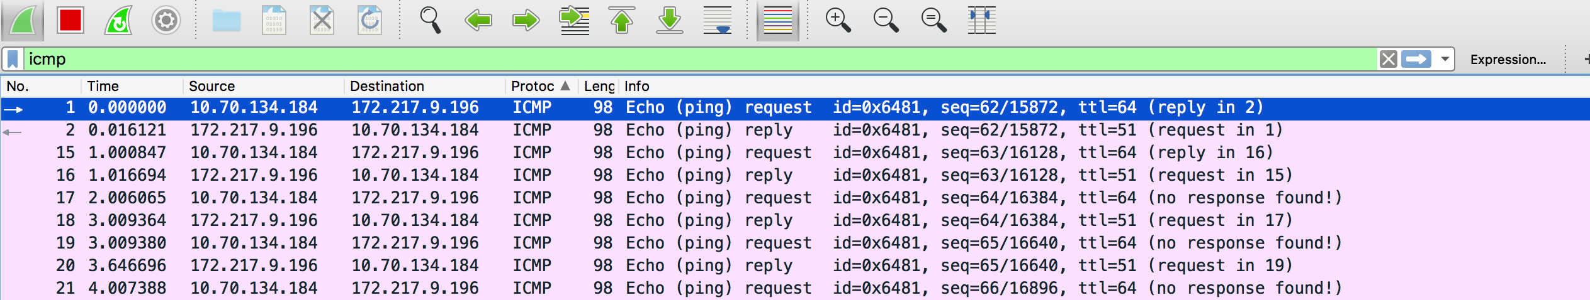

1. Use your web browser to open [www.southernct.edu](http://www.southernct.edu) and use wireshark to capture the HTTP packets. How long did it take from when the HTTP GET message was sent until the HTTP OK reply was received? (Screenshot is required)

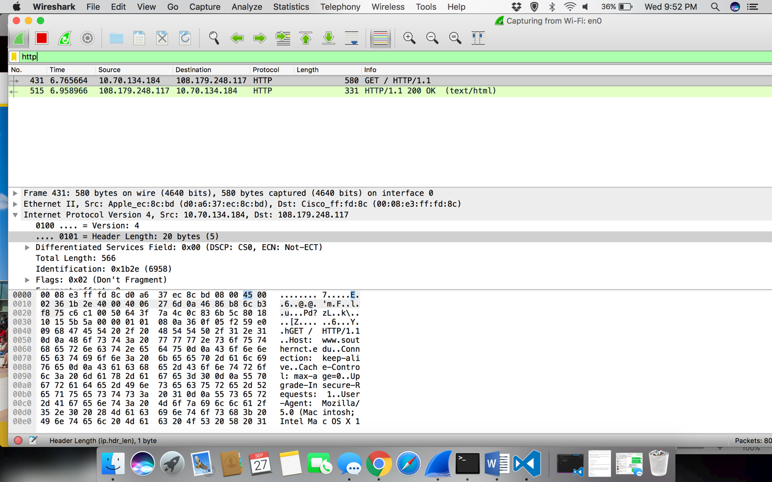

Answer: As shown in the screen, the Get was sent at 6.765664 and the reply was received at 6.958966. The delay was 0.192996.

1. Try to visit other different websites such as [www.google.com](http://www.google.com), [www.microsoft.com](http://www.microsoft.com), [www.amazon.com](http://www.amazon.com), and etc. Can you capture HTTP packets from wireshark when you visit these website? Explain your findings.

Answer: Yes, you can capture HTTP packets from wireshark from the website that you visit but I would take a bet longer. But the difference that with each enter from the website your get a new capture every time from the http and you have to check source it comes from to see the get and ok.